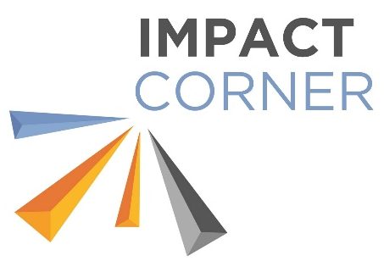
2026 School Age Summer Camp
Registration Form
This form and payment is due to the Impact Center office
no later than 10 days prior to the start of the Camp
you are registering for

Enrollment is not complete until all required paperwork is obtained from the
Impact Center Office, completed, and returned

Child’s Name: _________________________________________________________________________________
Address: ______________________________________________________________________________________
Parent’s Name(s): ___________________________________ _______________________________________
Parent’s Phone Number(s): ________________________________ ____________________________________
Please indicate the Summer Camp(s) your child will attend:
- Blast from the Past Camp: May 26-29 (due May 15)
Daily Schedule:
8:45 a.m. Drop-Off
9:00 a.m. S.T.E.A.M. Activities
11:00 a.m. Lunch
Noon Garden Group/Reading/Prep Time
1:00 p.m. Field Trip/Activity
3:00 p.m. Snack
3:30 p.m. Pick-Up

* Pick-up time may be later on field trip days. All changes will be communicated to parents ahead of time.
- Culinary Camp: June 1-5 (due May 22)
- Nature Camp: June 8-12 (due May 29)
- Circus Camp: June 15-19 (due June 5)
- Career Camp: June 22-26 (due June 12)
- Pyrotechnic Camp: June 29-July 3 (due June 19)
- Under the Sea Camp: July 6-10 (due June 26)
- Camping Camp: July 13-17 (due July 3)
- Christmas in July Camp: July 20-24 (due July 10)
- STEM Camp: July 27-31 (due July 17)
- End of Summer Camp: August 3-7 (due July 24)
- Back to School Camp: August 10-14 (due July 31)

- Check here if you would like your child to eat breakfast for an additional $10/week.
Children eating breakfast at the Center must arrive before 8:30 a.m. Breakfast will be put away by 8:45 p.m.
Children not eating breakfast should arrive at 8:45 a.m.

Number of Camps: ______________ x $130 each = ________________________
Weeks of Breakfast ______________ x $10 each = _________________________ (optional)
Pool Pass # ______________ OR $12.00 for swimming each week = __________
TOTAL ENCLOSED: _________________
Return form and payment to: Impact Center, 902 12th Street, Gothenburg, NE 69138 or
Impact Corner, 710 12th Street, Gothenburg, NE 69138
Questions? Call Siera at 308-351-5011 or email director@myimpactcenter.com

